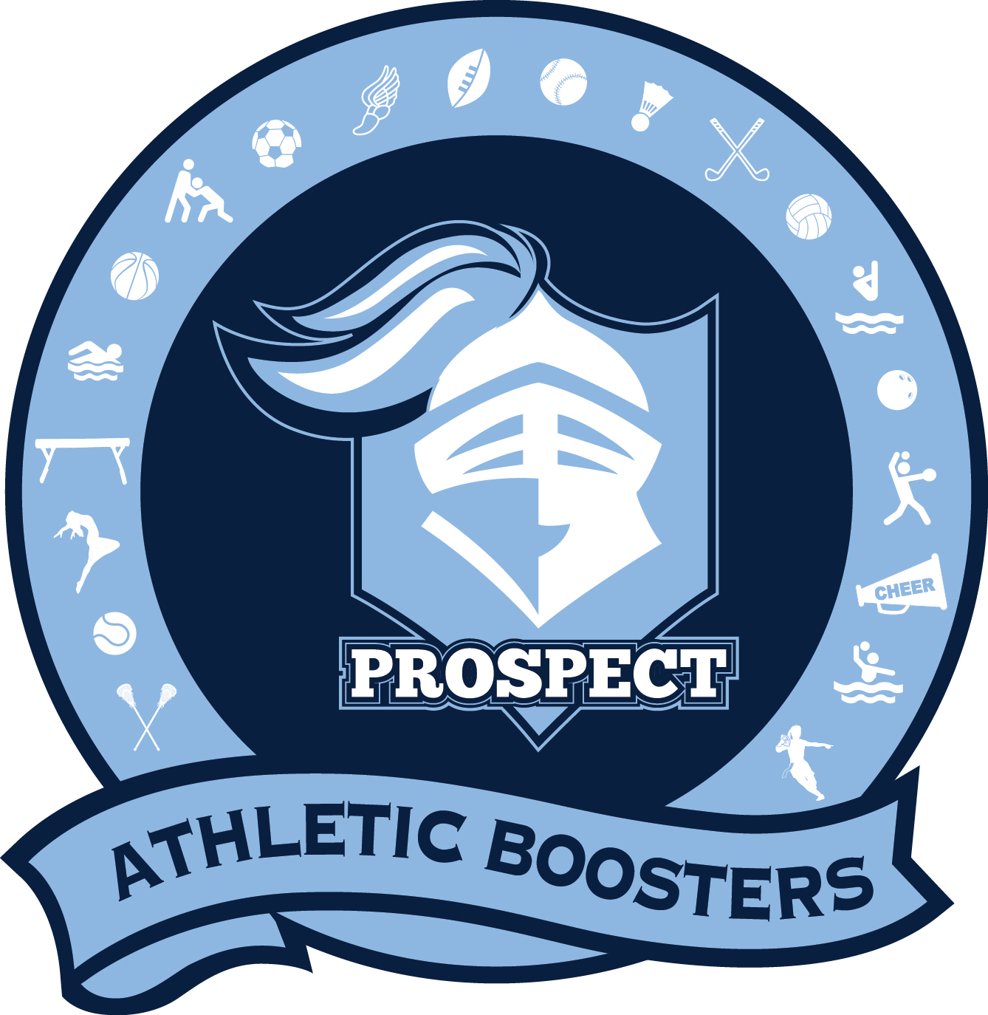
Executive Board
Dan Sommers & Michelle Lanza
Co-Presidents
Amy Neumann – Secretary
Rob Robinson – Treasurer
Chris Welter – Membership
Jennifer Hong – Social Media
Jamie Machel – Spirit Wear
#30Strong #GoKnights

Monthly Meeting Agenda - April 8th, 2024
- Call to Order and Introductions
  - Welcome
  - Executive Board
  - Members in Attendance
  - Vote to Approve Meeting Minutes from previous meeting
- Executive Board Report
  - Co-President Report – Dan Sommers / Michelle Lanza
  - Treasurer Report – Rob Robinson
  - Membership / Boostership Report – Chris Welter
  - Social Media Report – Jennifer Hong
  - Spirit Wear Report – Jamie Machel
- PHS Athletic Department and Administration Report – Scott McDermott
- Standing Committee Updates
  - Golf Outing - Brendan Friar/Eric Caravello
  - Re-U-Knight Service Project – Ann Cantieri
  - Boosterpalooza – Dan Sommers
- Athletic Team Updates
- Old Business
- New Business
- Adjourn Meeting

